I remember the first time I sat down with my husband and decided to create a budget. We were both frustrated and annoyed; however, determine to stop living paycheck to paycheck. That day we decided to do something about it. These are the steps we took.

1. We wrote down our household income
2. We wrote down our monthly expenses
3. We discussed unhealthy spending habits
4. We established some goals and made a budget plan for next month

Wow, what an eye-opener! We were spending money with no real purpose. I realized we needed a Money Management Tool to save us money and increase cashflow in our household. When you know better, you do better.

I understand how stressful money management can be, especially when you do not know where to start. This tool will be your road map so that you can take control of your Money. Which is one of the first steps on the “Financial Literacy Journey.”

Here are three simple things you need to get started.

1. Identify your financial goals (i.e., saving for a house, car, vacation, etc.)
2. Review previous month expenses
3. Create a budget for the upcoming month by allocating all your funds under the appropriate categories.

Yes, this will be challenging, but remember to be consistent and intentional. Take back control of Your Money and increase savings, investment opportunities, family vacation time, retirement funds, and so much more.

Instructions:

- Fill in the Expense name (when necessary)
- Fill in the “expected” or “budget” amount
- Once paid, enter the “actual” amount

As shown below.


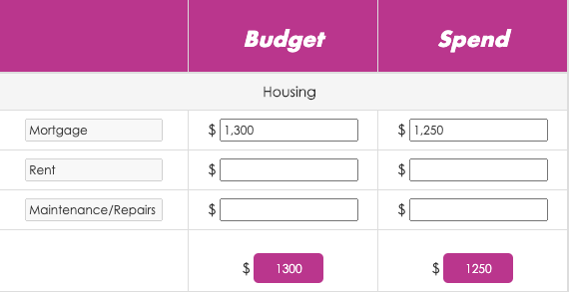

We have created a graph that shows your budget vs. actual expenditures for the month as a bonus.

Let’s get ready to Focus, Yield and Elevate your financial literacy!

Changes to be made to Budget vs Actual.

- Change name of file to Monthly Budget
- Move the areas to be shown as indicated below: (Please pre-fill some rows with data below, blank space indicates areas where items can be written in by client)
**Don’t include the letters or numbers next to each word**
  - Housing Utilities
- Mortgage Water
- Rent Electricity
- Maintenance/Repairs Gas
  - Savings Giving
- Emergency Fund Tithes
- Vacation Fund Charity

  - Meals Education
- Restaurants College Tuition
- Groceries Student Loans

  - Entertainment Phone/Internet/Cable
    - Cell Phone
    - Internet
    - Cable/Streaming
  - Travel Personal Care

  - Pet Kids Activities

  - Medical Vehicle
    - Insurance Car Note
    - Doctor’s Visits Fuel
    - Prescriptions Maintenance/Repairs
    - Dental Insurance
    - Vision
Credit Cards Loans (Other)

Investing/Retirement Other
    - 401K/IRA
    - Stocks/Bonds

- Center the headers for the areas “Housing”, “Utilities” etc.
- Change “Actual” to “Spend”
- Chart should be shown in $ not %
- Remove the word “Actual” from the headers and only allow name to show when you hoover over the bars.
  - 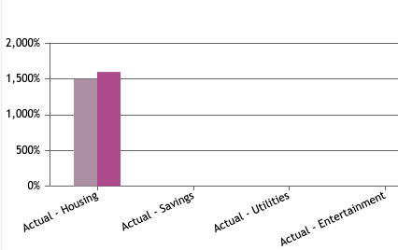
- Please make sure all $ are in number format with comma (as shown below)
  - 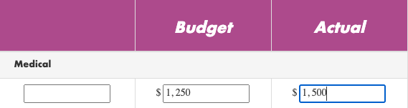
- Use the font as shown in this document for the font of the text in the introduction.

